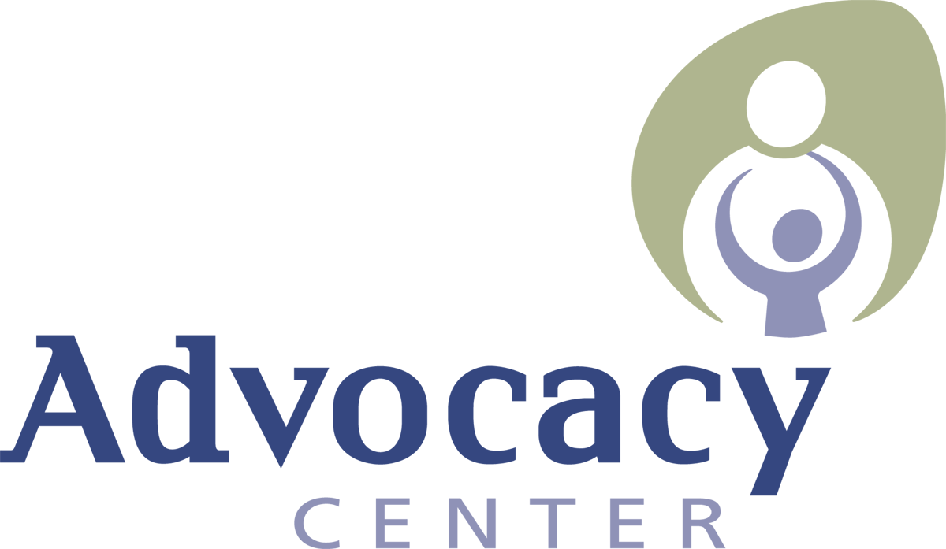
Domestic Violence and Sexual Abuse Services

JOB ANNOUNCEMENT

Position: Grants Manager (20 hours/week)
Salary: Part time $18.25 hr with generous benefits
Start Date: ASAP

The Advocacy Center seeks a part time, 20 hours per week, Grants Manager who will be responsible for the management of agency service data and efficient and accurate reporting for internal, local, state and federal grants. This includes management of client data management system. The Grants Manager will determine the types of data to be collected to meet grant objectives, will be responsible for timely and accurate submission of data and workflow processes related to data collection, and will oversee the continual improvement of data collection systems, processes and policies including quality assurance processes.

Our generous Benefits Package includes an annual financial contribution ($6,675 in 2021 prorated to start date) towards our cafeteria health benefits program (includes individual medical, dental or dependant care benefits or expense reimbursements), generous time off (2 weeks vacation the first year increasing thereafter, 16 paid holidays, 5 personal days, sick days) and annual retirement contributions after 3 years of employment.

This is an in person position that has the possibility of some remote hours once training is complete.

Located in Ithaca, NY, the Advocacy Center provides a wide range of support services to adult and youth survivors of domestic violence, child sexual abuse and sexual assault. We are an organization whose roots are based in feminism, social change, and victim rights. We are dedicated professionals with a strong work ethic who also promote self-care and wellness as we value a healthy work/life balance. We provide extensive training to our staff and are committed to strong supervisory support and professional development opportunities.

The ideal person for this job is someone who enjoys collaboration and works effectively alone. Much of this position tends to be solo work with bouts of close collaboration and communication with multiple parties. This person is task oriented, enjoys checking things off a list, and is able to easily switch between various platforms, software and databases. It is imperative that the right candidate have a proven ability to learn new platforms quickly and easily. This position requires a numbers mindset and a passion for timeliness, deadlines, and accurate data.

Physical Requirements: applicants must be able to ascend/descend stairs, periods of sitting, computer use. Standing and movement required.

TO APPLY: Please review qualifications and submit two separate documents (in MS Word or PDF format only): 1. Cover Letter and 2. Resume Please submit as two separate attachments to an email to jobs@actompkins.org. Applications will be accepted until the position is filled.

QUALIFICATIONS

- Experience with non-profit grant reporting or experience using databases to track data and generate reports
- Advanced knowledge in Microsoft Office Suite
- Knowledge of Google for Business platform helpful
- Solid planning and organizational skills with high attention to detail, accuracy, protocol and deadlines.
- High level of flexibility and responsiveness with the ability to shift priorities quickly and as organizational demands require.
- Experience with database entry and structure of queries/reports
- Strong interpersonal and collaborative skills
- Flexible schedule
- Commitment to working from an anti-oppression, harm-reduction, and strengths based trauma-responsive approach
- High level of discretion in maintaining confidentiality of sensitive materials and issues.

