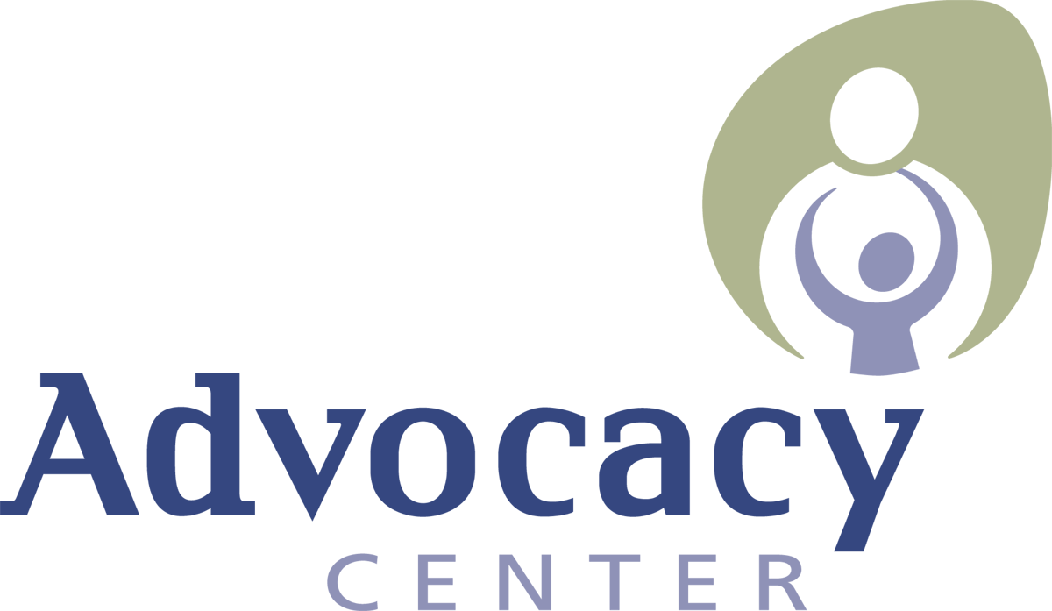
Domestic Violence and Sexual Abuse Services

JOB ANNOUNCEMENT
Position: Administrative Assistant - Full Time (35 hours/week)
Salary: $16.34/hour with generous benefits
Start Date: ASAP
This is an in-office position.

TO APPLY: Please review qualifications and submit two separate documents 1. cover letter and 2. resume (in MS Word or PDF format only). Send the 2 attachments as an email to: jobs@actompkins.org.

Applications will be accepted until the position is filled.
Our progressive social service agency seeks a full time Administrative Assistant to support the work of the agency. This front office position is an important component of our team, providing broad-based administrative support for the office, conducting all matters pertaining to the front office, and serving as the first point of contact for Advocacy Center clients and visitors, setting a welcoming and professional tone. Responsibilities include office reception, answering the phone and triaging calls, administrative support for Executive Director and Leadership Team, logistical assistance with special events, managing and ordering office supplies, primary office contact for maintenance needs and coordination with repair vendors, updating and maintaining staff orientation materials and manuals, and performing other duties as assigned.
The Advocacy Center of Tompkins County www.actompkins.org, located in Ithaca, NY, is an organization whose roots are based in feminism, social change, and victim rights. We are proud of our workplace culture. We are dedicated professionals with a strong work ethic who also promote self-care and wellness as we value a healthy work/life balance. We combine seriousness of purpose and commitment to our mission with a sense of kindness and humor toward one another.

The Advocacy Center is committed to diversity, equity, and inclusion. We believe we have the most impact when people with a wide range of backgrounds, experiences, and identities come together with common purpose. We encourage candidates from all backgrounds and identities to apply.

Excellent Benefits Package (prorated based on start date):
Agency contribution of $6,675 towards our cafeteria benefits program which includes individual health, dental or dependent care benefits or expense reimbursements (prorated for part time employees and for employees starting after the 1st of the year), generous time off (2 weeks vacation the first year increasing thereafter, 16 paid holidays, 5 personal days, 12 sick days), and retirement contribution after three years of employment.

Physical Requirements: Applicants must be able to ascend/descend stairs, have the ability to lift up to 25 pounds to a height of 2-3 feet.

QUALIFICATIONS
Required

- Associate’s degree or equivalent work experience.
- One year of administrative support or office management experience, additional experience preferred.
- Ability to work independently as well as in a team.
- Experience that demonstrates sound judgment, creativity, time management, and problem-solving skills.
- Attention to detail and organizational skills are critical for this position.
- Demonstrate a history of reliability.
- Demonstrated ability to maintain strict confidentiality and to handle sensitive situations with tact and discretion.
- Willingness to appreciate different points of view and problem solve in a constructive manner.
- Sensitivity to the impact of sexual and domestic violence in diverse and marginalized communities and the ability to articulate these concerns in a sensitive and respectful manner.
- Excellent verbal and written communication skills.
- Proficient in standard office software such as Microsoft Office. Experience with Google G Suite desired, but not required.
- Demonstrated ability to establish and maintain effective professional working relationships.

